EXPERIMENT NO. 07
STUDY AND IMPLEMENTATION OF DATABASE AS A SERVICE (DBaaS)
CLOUD SERVICE MODEL ON A SQL / NoSQL DATABASE

1. Aim
To study the Database as a Service (DBaaS) cloud service model and understand its implementation using a managed SQL database and a managed NoSQL database.

2. Objectives
- Understand DBaaS and its role in cloud computing.
- Differentiate relational SQL databases from document-oriented NoSQL databases.
- Study the responsibilities handled by the cloud provider and the customer.
- Perform basic create, read, update, and delete (CRUD) operations on both database types.
- Identify security, availability, backup, scaling, and cost considerations.

3. Theory

3.1 Database as a Service (DBaaS)
Database as a Service is a cloud computing model in which a provider offers database software and its supporting infrastructure as a managed service. The database is accessed over a network through a database endpoint, driver, or API. Depending on the service, the provider can manage provisioning, operating-system maintenance, database patching, backups, monitoring, replication, and recovery. The customer remains responsible for data design, access permissions, application queries, and appropriate security configuration.
DBaaS reduces the need to install and maintain database servers manually. Capacity can often be increased or decreased through configuration, and billing is typically based on the selected resources, storage, data transfer, or service tier.

3.2 SQL database
A SQL database is generally relational: data is stored in tables containing rows and columns, and relationships are represented using keys. SQL supports structured queries and constraints. Relational databases are suitable when data consistency, transactions, joins, and a defined schema are important.
Example used in this study: PostgreSQL through a managed service such as Amazon Relational Database Service (Amazon RDS).

3.3 NoSQL database
NoSQL databases support data models other than the traditional relational-table model. A document database stores records as flexible documents, commonly represented using JSON-like structures. Documents in the same collection can have different fields, which can be useful when application data evolves or contains nested structures.
Example used in this study: MongoDB through MongoDB Atlas, a managed cloud database service.

3.4 DBaaS architecture
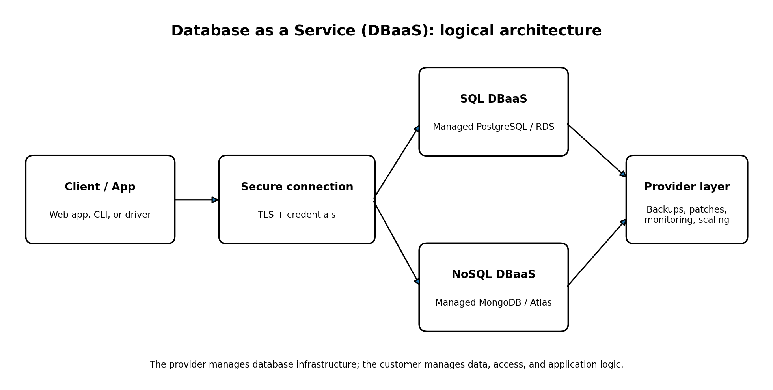
Figure 1: Conceptual DBaaS architecture showing an application connecting securely to managed SQL or NoSQL databases.

3.5 Responsibilities in DBaaS
Provider typically manages | Customer typically manages
Database service provisioning and underlying infrastructure | Data model, schema/collections, and application logic
Service maintenance and supported database patching | Database users, roles, and least-privilege access
Managed backup and recovery features (when enabled) | Backup retention choices and recovery testing
Monitoring and service availability features | Query efficiency, data quality, and application-level security
Scaling options provided by the service | Capacity selection, cost monitoring, and secure network rules

4. Requirements
- A computer with internet access and a modern web browser.
- An account for a cloud DBaaS provider (for example, AWS for RDS and MongoDB Atlas for a document database).
- A SQL client such as psql, pgAdmin, or a database query editor.
- A MongoDB client such as mongosh, MongoDB Compass, or the Atlas Data Explorer.
- A sample dataset and permission to create a test database.
Cost note: cloud providers may charge for database instances, storage, backups, network transfer, or related services. Use a permitted student/free tier where available, review the current pricing before deployment, and delete test resources after the experiment.

5. Implementation A — SQL DBaaS using managed PostgreSQL

5.1 Provisioning procedure
- Sign in to the cloud provider console and open the managed relational database service (for example, Amazon RDS).
- Choose Create database and select PostgreSQL as the database engine.
- Select a development/test template or the smallest suitable permitted configuration. Set a unique DB instance identifier and a strong administrator password.
- Configure storage and availability options appropriate for a lab. Avoid production-sized resources for a simple experiment.
- Configure connectivity. Prefer private networking where possible. If public access is necessary for a temporary lab, restrict inbound access to the current client IP rather than allowing all addresses.
- Create or select a security group/firewall rule for PostgreSQL TCP port 5432 from the approved source only.
- Create the database and wait until the service reports that it is available. Record the endpoint, port, database name, and username; do not include passwords in the report.
- Connect using the provider's query editor or a PostgreSQL client with TLS enabled where supported.

5.2 Create a sample table and perform CRUD operations
The following SQL illustrates the test. Run it only in a database you own or are authorized to use.
CREATE DATABASE dbaas_lab;
-- Connect to dbaas_lab, then run:
CREATE TABLE students (
student_id INT PRIMARY KEY,
student_name VARCHAR(80) NOT NULL,
department VARCHAR(30),
semester INT
);
INSERT INTO students (student_id, student_name, department, semester)
VALUES
(1, 'Aarav Shah', 'Computer', 5),
(2, 'Mira Patel', 'Computer', 5);
-- Read records
SELECT * FROM students ORDER BY student_id;
-- Update a record
UPDATE students SET semester = 6 WHERE student_id = 1;
-- Delete a test record
DELETE FROM students WHERE student_id = 2;

5.3 Expected verification
A successful SELECT should initially return two student records. The UPDATE statement should change Aarav Shah's semester to 6. The DELETE statement should remove the record with student_id = 2. Confirm the affected-row counts and run SELECT again to verify the final state.

5.4 SQL implementation observations
- The table has a defined schema and a primary-key constraint.
- SQL statements can filter, join, aggregate, and update structured records.
- The DBaaS endpoint separates the application from the physical database host.
- Network access should be restricted and credentials should not be committed to source code.

6. Implementation B — NoSQL DBaaS using MongoDB Atlas

6.1 Provisioning procedure
- Sign in to MongoDB Atlas and create a project for the lab.
- Create a database deployment using an available development/free option if eligible. Review the current plan and region choices.
- Create a database user with a strong password and only the permissions required for the test.
- Configure Network Access to allow only the client IP address needed for the lab. Avoid broad access rules such as 0.0.0.0/0 unless there is a specific, temporary, justified need.
- Open the deployment's Connect instructions and choose a supported client such as mongosh, Compass, or the Atlas web data explorer.
- Copy the connection string and replace its placeholders with the database username and other required values. Keep credentials private.
- Connect to the deployment and select a database named dbaas_lab.

6.2 Create a collection and perform CRUD operations
The following commands are examples for mongosh. If the Atlas web editor is used, adapt the commands to the interface it supports.
use dbaas_lab
db.students.insertMany([
{ student_id: 1, name: "Aarav Shah", department: "Computer", semester: 5 },
{ student_id: 2, name: "Mira Patel", department: "Computer", semester: 5 }
])
// Read documents
db.students.find({}, { _id: 0 }).sort({ student_id: 1 })
// Update one document
db.students.updateOne(
{ student_id: 1 },
{ $set: { semester: 6 } }
)
// Delete one test document
db.students.deleteOne({ student_id: 2 })
// Verify final state
db.students.find({}, { _id: 0 })

6.3 Expected verification
The initial find operation should return two documents. The update operation should modify the semester field for the document with student_id = 1, and deleteOne should remove the document with student_id = 2. The final find should return one document with semester 6.

6.4 NoSQL implementation observations
- Documents are stored in a collection and can contain nested or evolving fields.
- The query syntax is different from SQL, although the same CRUD concepts apply.
- Applications should define suitable validation and indexes for data quality and performance.
- Access rules, credentials, and connection strings must be protected.

7. Workflow
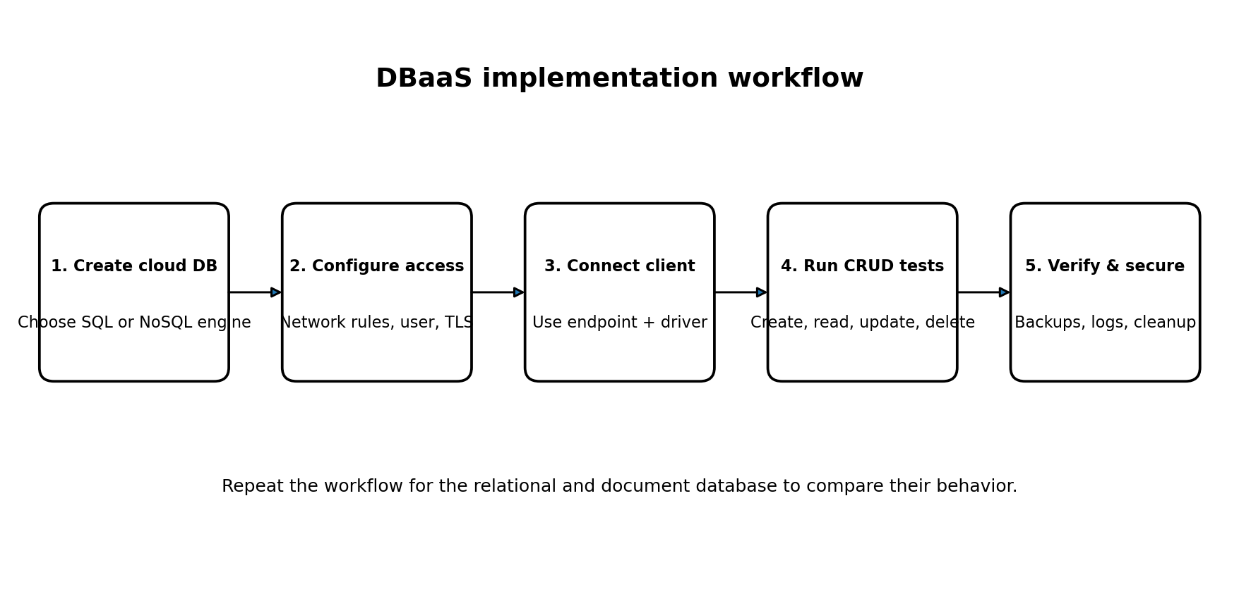
Figure 2: Recommended sequence for implementing and validating a DBaaS deployment.

8. SQL vs NoSQL comparison
Feature | SQL DBaaS (PostgreSQL) | NoSQL DBaaS (MongoDB document database)
Data model | Tables, rows, columns, relationships | Collections and JSON-like documents
Schema | Usually explicit and structured | Flexible; validation can be configured
Query style | SQL statements | Document query and update operators
Relationships | Joins and foreign keys are common | Embedding or references are common design choices
Transactions | Strong relational transaction support | Transaction support depends on deployment and operation; document design remains important
Good fit | Structured data, joins, integrity constraints | Nested or changing records and document-centric access
Key design concern | Schema, indexes, constraints, query plans | Document shape, indexes, validation, query patterns
Neither model is universally better. The correct choice depends on the application's data relationships, consistency needs, query patterns, scale, operational constraints, and cost.

9. Security and operational best practices
- Use least-privilege database accounts; do not use an administrator account for normal application access.
- Restrict network access to trusted IP addresses, private networks, or approved application services.
- Use encrypted connections (TLS) and store secrets in a secrets manager or protected environment variables.
- Enable backups and choose a retention period appropriate for the lab or workload. Test restoration rather than assuming backups are usable.
- Monitor database health, storage use, connections, slow queries, and billing alerts.
- Create indexes based on observed query patterns; unnecessary indexes can increase write and storage overhead.
- Delete or stop lab resources when finished, while checking whether storage or backup charges may continue.

10. Result / Output
The study and implementation procedure demonstrates how a managed SQL database and a managed NoSQL document database can be provisioned and accessed as DBaaS. The sample CRUD operations provide a repeatable way to verify connectivity and data manipulation. The result should be marked successful only after the commands have been run in the selected cloud deployments and their outputs have been checked.
Evidence to attach after performing the lab: (1) SQL service status and endpoint details with secrets hidden; (2) SQL query output before and after update/delete; (3) NoSQL deployment status; and (4) document query output before and after update/delete. The diagrams in this submission are conceptual illustrations, not screenshots of a live cloud account.

11. Conclusion
DBaaS provides database capabilities without requiring the user to manage all underlying database-server infrastructure. A managed SQL service such as PostgreSQL is suitable for relational data, structured schemas, joins, and integrity constraints. A managed NoSQL document service such as MongoDB Atlas supports flexible document-shaped data. Both require careful configuration of identity, network access, encryption, backups, monitoring, and cost controls. The implementation steps and CRUD examples demonstrate the basic workflow for studying and validating DBaaS.

12. Viva questions
What is DBaaS? A managed cloud service that provides database capabilities over a network.
What is the main difference between SQL and NoSQL? SQL commonly uses relational tables and a structured schema; NoSQL includes models such as flexible documents.
What does CRUD stand for? Create, Read, Update, and Delete.
Why restrict database network access? To reduce unauthorized access and exposure to attacks.
Why are backups important? They support recovery after accidental deletion, corruption, or service incidents.
What is a database endpoint? The network address used by a client to connect to the managed database.
Does DBaaS remove all customer responsibility for security? No. The provider manages parts of the service, but customers still manage data, permissions, credentials, and configuration.

13. References
- Amazon Web Services, Amazon RDS User Guide: https://docs.aws.amazon.com/AmazonRDS/latest/UserGuide/Welcome.html
- MongoDB Documentation, MongoDB Atlas: https://www.mongodb.com/docs/atlas/
- PostgreSQL Documentation: https://www.postgresql.org/docs/
- MongoDB Manual: https://www.mongodb.com/docs/manual/

